Boğaçhan Arslan 7/11/20

26569

CS 405

**Ray Tracing Project**

**Task 1: Basic Scene**

 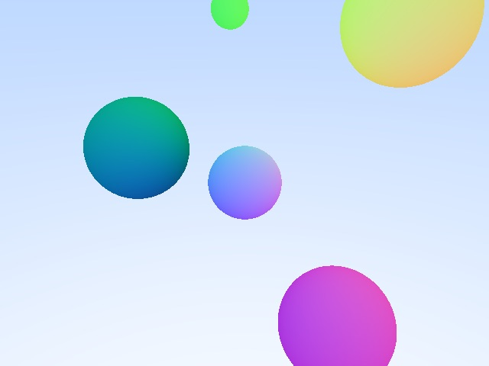

Camera origin = (0,0,5) Camera origin = (2,3,6)

Sphere positions:

* 1: center = (-1,3,2) | radius = 0.4
* 2: center = (2.5,2.8,-2) | radius = 1.2
* 3: center = (-3,0,-1) | radius = 1.2
* 4: center = (0,0,0) | radius = 0,7
* 5: center = (2,-2,1) | radius = 1

**Task 4: Diffuse & Metal Materials**

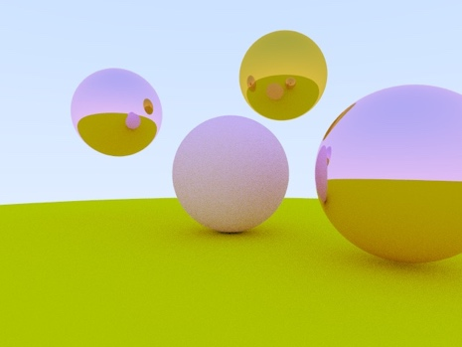

5 spheres. Three are metal and two diffuse material.

Pink-ish metal on top left & at the right -> Albedo: (0.9725, 0.6314, 0.902)

Yellow-ish metal on top -> Albedo: (0.8941,0.6078,0.0588)

Ground (huge green sphere) -> Albedo: (0.8, 0.8, 0.0)

Pink lambertian diffuse at the center -> Albedo (0.9725, 0.6314, 0.902)

**Task 6: Lights**

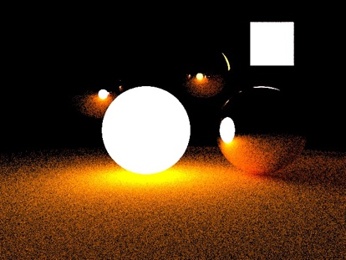 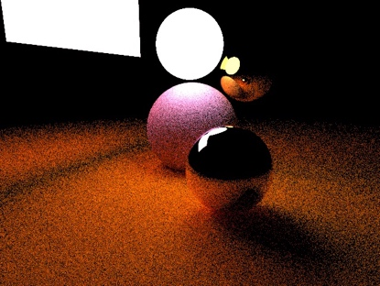

**Task 8: Questions**

* **The approximate time complexity of ray tracing on models with triangles.**

The approximate time complexity could be expressed as: x_res*y_res*sample_count * (shading_model + texture_model + log(#triangle)

* **What is the difference between preprocessing and computing the image? Why?**

**?**

* **What are the critical parameters for the ray tracer algorithm’s performance?**
* The time bound proportionality is based on the x & y resolution of the image as well as the sample count, which determines the recursion depth. Of course that time complexity increases with the texture and shading model.
* **Imagine you are a systems engineer at Pixar. There is a new super-resolution in 6000×6000 pixels and you have to estimate the maximum rendering time per frame. Assume that the scenes are static, so you are not going to spend any CPU on animation, scene hierarchy, etc. The average scene has 500 objects with a total of 5.000.000 triangles to check intersection with.**

6000 * 6000 * log(5000000)*500 = 396000000000 ms = 110 hours apprx.